Tower of Hanoi

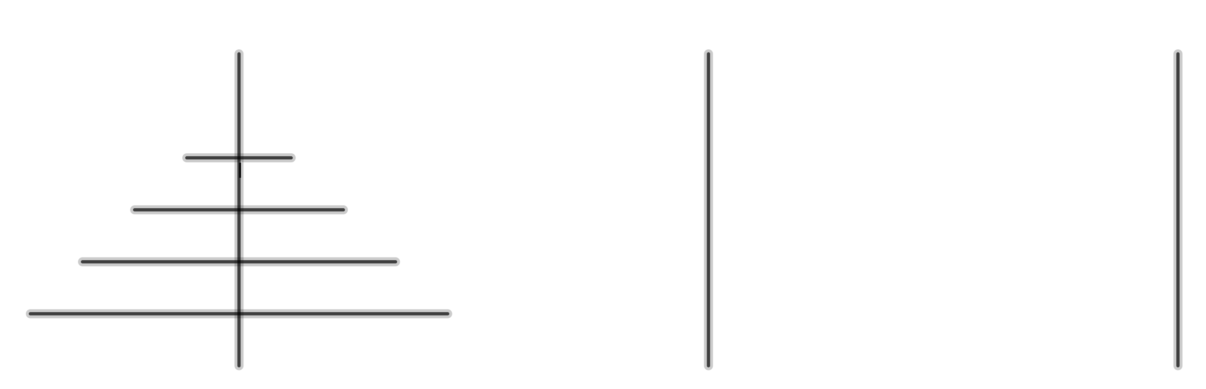

We have three posts. There are some discs on one of these posts. These discs are all different sizes. The discs are in order of size with the largest disc at the bottom and the smallest disc is at the top. We want to move all the discs from this post to another post. However, we can only move one disc at at time and we cannot put a disc on top of a smaller disc.
Let’s call the discs A, B, C, … with disc A being the smallest, disc B being the next smallest ...
We start with two discs, A and B on post 1. We make these moves:
A to post 2 then B to post 3 then A to post 3. Try it.
Now the discs are all on post 3. So to move two discs we need three moves.
We start with three discs, A and B and C on post 1. We make these moves:
A to post 2 then B to post 3 then A to post 3 then C to post 2 then A to post 1 then B to post 2 then A to post 2. Try it.
Now the discs are all on post 3. So to move three discs we need seven moves.
I’m not going to write out all the moves required to transfer four discs. It’s time to stop and think.
We start with four discs A and B and C and D on post 1. To move D, we first have to move A, B and C to another post. We know this takes seven moves. Then we have to move D. This takes one move. Then we have to move A, B and C back on top of D. This takes another seven moves.
So to move four discs we needmoves.
Letbe the number of moves to movediscs.
So
In general:
and
We want a formula forWe will use the guess and prove method.
Guess:

EXERCISE
Use proof by induction to show that this guess is correct

SOLUTIONS
Proof part 1:
Ifthen andSo the formula is true when
Proof part 2:
Ifis true whenthen:
but

Sois true when
So our guess is correct.

